Statistics And Probability:

Data:
A set of information is called Data. For every operation of analysis,machine learning,deep learning and vice versa we need data to perform operations.

How To Store Data:

Data Table:
We store data in form of tables which is known as Data Table.
We also have rows and columns in this data.
Columns
Rows

One Way Table:

Suppose there are 2 columns one is Name and other is Age. Here we can say Name is a individual and age is a variable because individual has dependencies on multiple things.

Name | Age | Salary | Gender
Shahzaib | 19 | 0 | M

Here in the above table u can see name is acting as individual and others are acting as like variables because when someone asks age about a particular person he/she has to ask it using the name here name act as an independent individual while others act as a variable.

The variables that are divided based on the category we call them Qualitative Variables while which are not divided in any category we call them as Quantitative Variables. Here in the above example gender is qualitative variable while age and salary are quantitative variables.

A more proper definition of both are as follows:

Continuous numeric data like age,salary,height and etc are known as Quantitative Variables.

Where as categorical data like gender,genre and etc are known as Qualitative Variables.

DATA VISUALIZATION

Bar Graph:
Its the simplest and the most common graph the thing is that if we have data of the most liked fruit by people to manually verify it we need to count it but in statistic we can do it by visualizing a graph.
To create a bar graph first we need to create a frequency table for fruits.
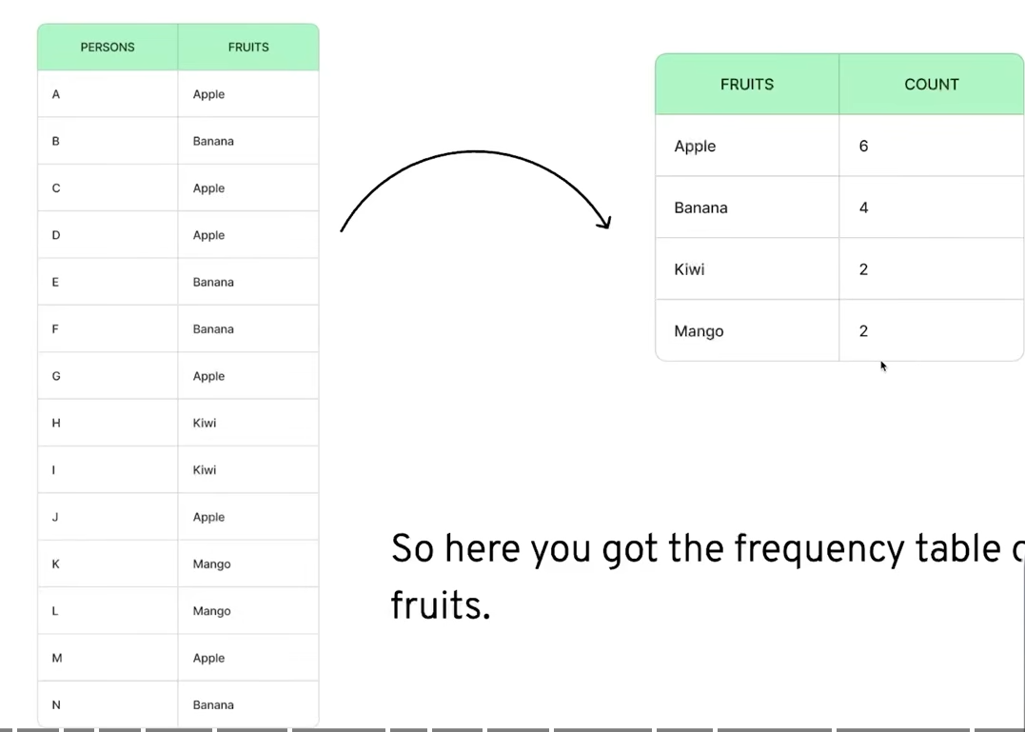
After finding the frequency of the fruit or the count then we can draw horizontal lines each line tells the specific frequency of the fruit we can then easily plot the graph. The underline approach and the plotted graph image are as follows:
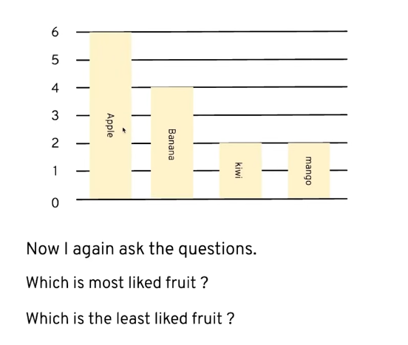
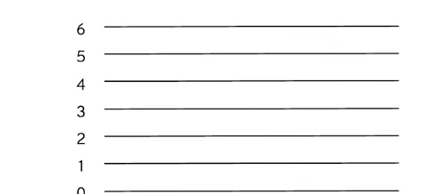

Pie Chart:
Now lets see pie chart it uses the frequency approach just like the bar graph but here we use the percentage occurrence approach.

Lets take a look on the frequency of the fruits data lets see that but the twist is that we will be converting those numeric data into percentage.

Formula→ No. Of Frequency * 100 Total No Of Fruits Frequency

Mathematical calculations are done in the register please refer to that

Apple → 42.9%
Banana → 28.6%
Kiwi → 14.3%
Mango → 14.3%

For creation of the pie chart in the back-end a circle is created then it is divided with the percentage data that we have calculated and ultimately something like this is made:
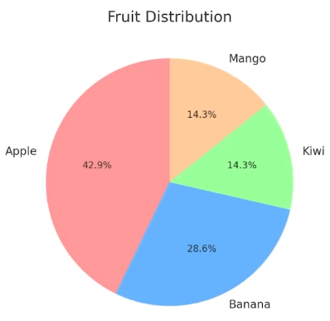

Line Graph:
Line graph are interesting but for making it we need to look backwards towards bar graph.
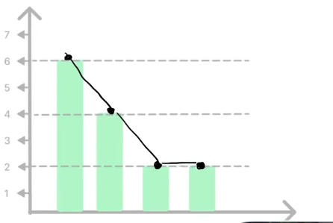
For understanding lets look at the bar graph we created now lets add dots on the top of the bars and connect them.

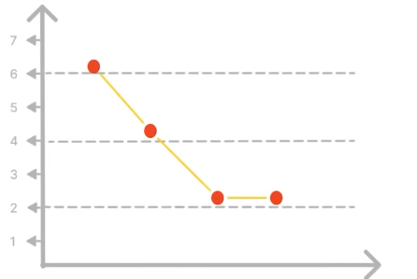
After that remove the bars boom here we go we got our very own line graph.

Question: Now when to use bar graph and when to use line graph??

Answer: To explain this we will be using a data of monthly expenses.
Here u can see we cant calculate the frequency of the data here but we can only plot a simple bar graph which cant show the flow. In short we will use bar graph when we have frequency of data and we will be using line graph when we have to see a trend like here I am attaching the picture of the line graph that will be made for this data which is attached on the next page.

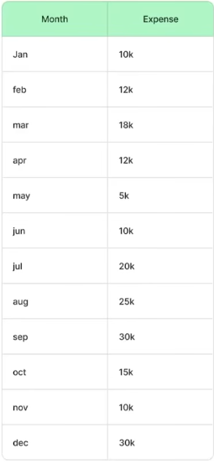
Data Line Graph
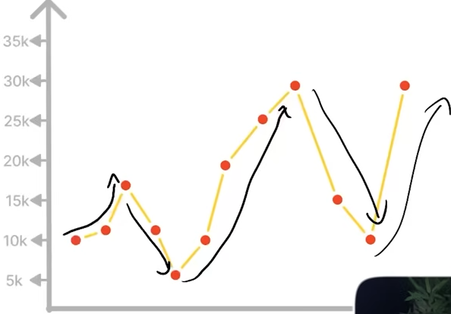

Here we can see it showing the flow of trend like the expenses flow from month 1 to month 12 this is the core reason to create a line graph.

O-Gives:
To create an o-gives we have to take out cumulative frequencies.
So now what is cumulative frequencies lets calculate what is it:

Cumulative Frequencies → I have attached the table below now the situation is that we create 2 tables one is of the default expenses and the next table is we will be adding per month expense like in Jan we have 10k expenses and for Feb we have 12k expenses and for march we have 20k expenses now we have the data for the cumulative frequency table we will be doing like this. For Jan it stays the same as 10k and for Feb it will now be 22k (10k of Jan + 12k of Feb) and for march it will now be 42k (10k of Jan + 12k of Feb + 20k of Mar).
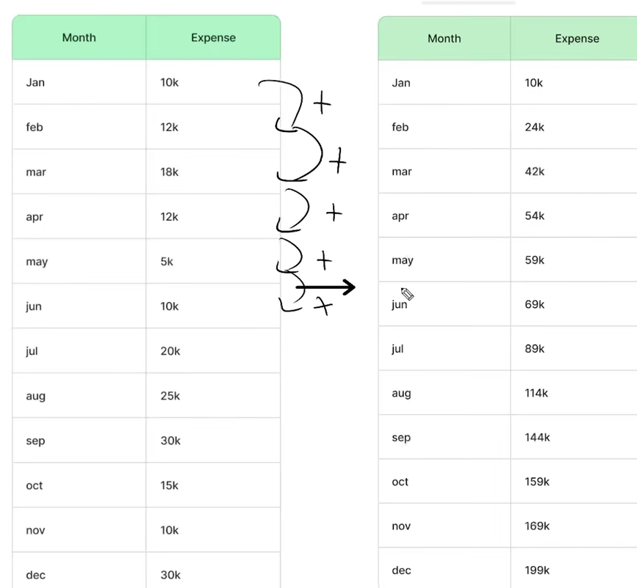

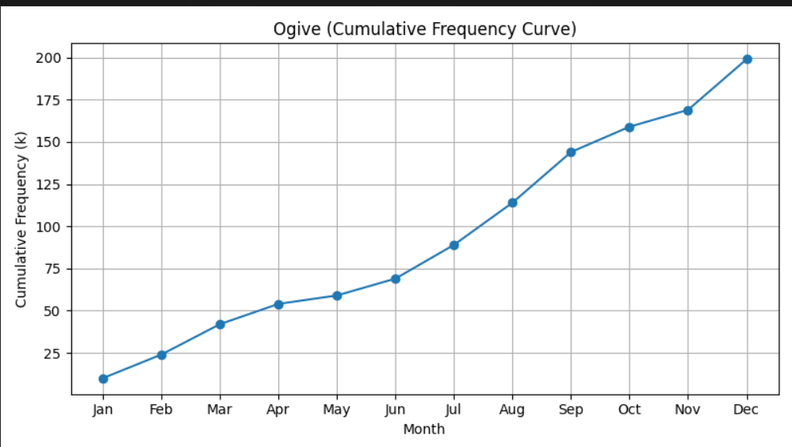
Now the line graph that will be plotted on the basis of cumulative frequencies will be known as O-Gives.
Which is drawn here→

Two Way Table:

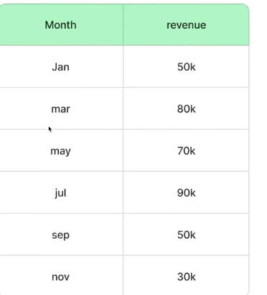
Currently the table we have on the right is a one way table. Lets assume this table is of data of the period of revenue of 4 years like from 2020-2023 now we can break it down as follows because we don’t have separate data of each year we only have a combined data so we will break it down as follows:
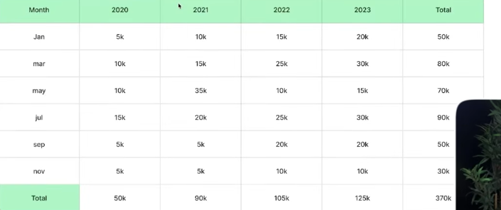

now this is a two way table because now month is not only the independent thing like if someone asks a revenue from us we will be asking two questions like for which month and which year. Dependencies has switched from a single month to a year too. Now if someone asks us when was the revenue 35k we can tell them it was in the year 2021 in the month of May.

Now using this data we can create a line graph for each year. Or even a bar graph for each year
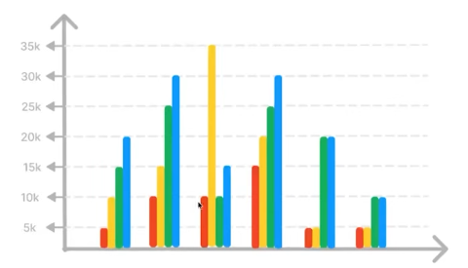

In 2 way table there is a thing known as Dot Plot its basically a bar graph with dots stacked on each other. To create that we basically need frequency of specific data which fulfill the need.
Which needs data like this →
It helps to build understanding for histogram.
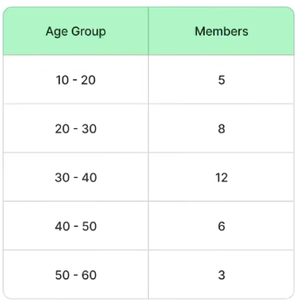
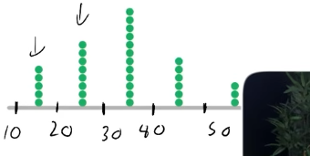

Dot Plot of the data

Relative Frequency Table:
A relative frequency table can be made through both one way and two way table but most of the data we see around is two way so we will focus on that

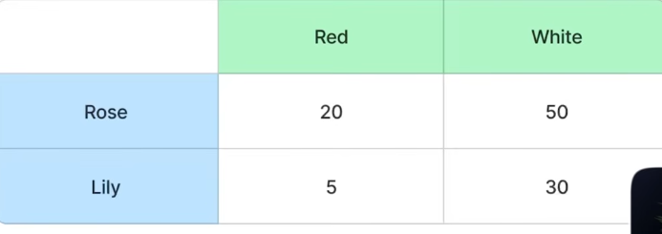
Data→

(its a two way table because there is dependencies on two things the color and the flower like if someone asks us where is 20 so u will be telling them in red column and rose rows something like that I hope u got my point)

Now lets calculate the column frequency of the data for which we will be calculating the frequency from 100. (For detailed calculations refer to the notebook we have done calculations there)
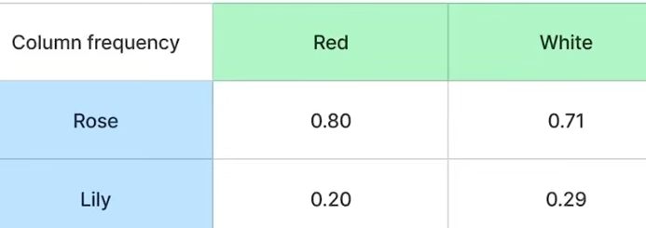
the white ones are different its due to a mathematical error u can see the notebook for instance.
Formula for calculating→ No. of An Element*100
Total Number
We have calculated the column frequency so if we total the column frequency we will be getting 100% but not for rows. Fortunately we can also calculate row related frequencies.

We do this because in Machine Learning We Mostly need to convert numeric data into 0s and 1
Joint Distribution:
A joint distribution table is similar to relative frequency table as it also contains percentage. This table compares two different distributions in a single table.
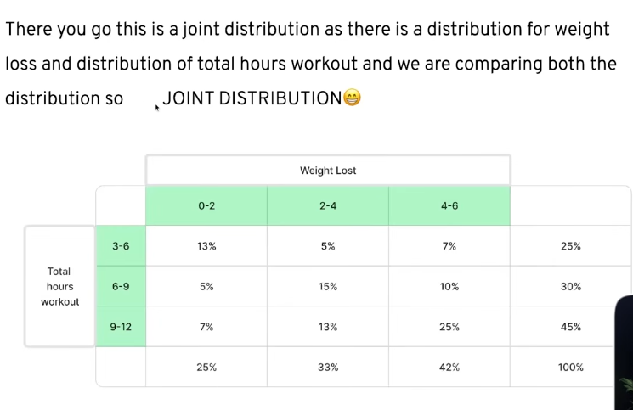
So we can say if we join 2 way tables and we use percentage and total percentage comes at 100% this is called as joint distribution.

Histogram:
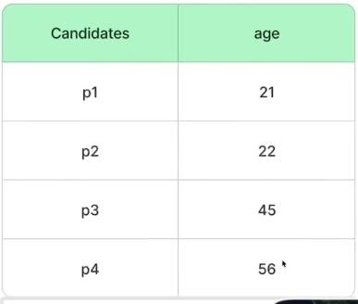
Histogram looks actually like a bar graph but here we group the data into buckets or bins.
We will be seeing using this data→

This data is incomplete it has multiple rows but for adding this here we are using only this data.

Now for making histogram we will be using x-axis and we will be creating bins just like this:
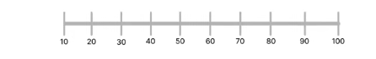
these bins are created using range function :).
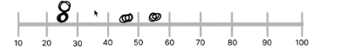
Now in these bins we will put the candidate into their desired bins using their age. Just like the image I have attached→
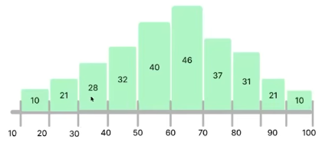
The more the number of data in the bins the more tall the histogram becomes

Now lets work on actual data
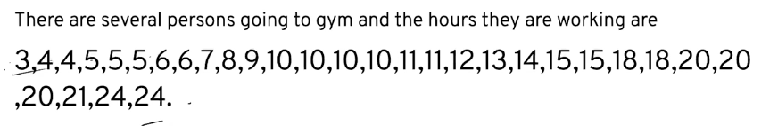
Now lets calculate the range of this to calculate the range we use the formula → Range = Rmax-Rmin
here max is 24 and min is 3 so range is 21
For creating bins we usually have to play around like here we can do is divide the range with 6 21/6 = 3.5.
For safe side we will round it of to 4 and the bins we will have is.
1-5,6-10,11-15,16-20,21-25
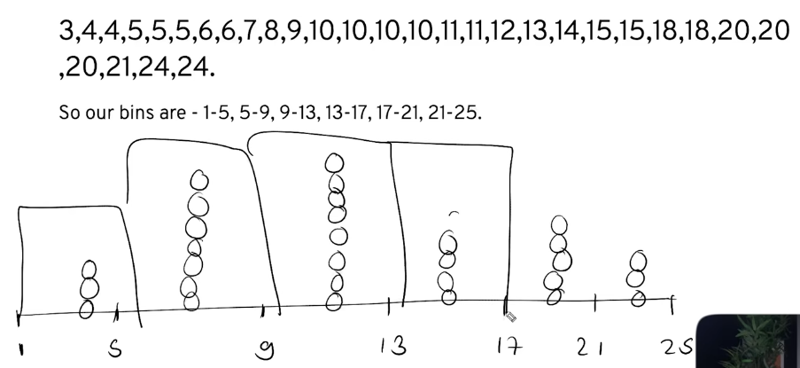
Question: Why and When we use Histogram?
Answer: We use Histogram when we have quantitative data, and we use it to group that data into buckets called bins so we can see the shape or spread at a glance like whether most values are clustered together, spread out evenly, or piled up on one side instead of having to read through a long list of raw numbers to figure that out.

DATA ANALYZING

In this section we will be focusing how we can do things mathematically to better understand our data

Measure Of Central Tendency:
It means it is the way we can describe the middle part of our data. The importance of middle part of the data we will see it further in the course why is it this much important.

Mean → The first way to find the middle part of the data is mean. It is also known as average.

Example → Here we have data 1,2,3,4,5. Here 3 is the middle part because its continuous data like equal spacing between elements.

But when it comes to non continuous data lets see it. Here we have data 2,2,7,9,10.

Formula → Sum of all numbers / total numbers

Mean = 6 for the non continuous data refer to the notebook for detailed calculation
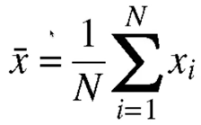
Fancy representation of this formula is statistic →
Details of this are mentioned in notebook

Median → The second way to find the middle part of the data. It doesn’t necessarily need to be calculated through mathematical formulae it is simple.

Example → 4,7,9,10 The middle part of this data is 7 and 9 so we will add them both and divide them by 2 we will get 8 and 8 will be the middle point of this data.
Another example 1,2,6,7,9 no need for calculation here we can exactly see that 6 is the midpoint like on the left of 6 we have 2 elements and on the right too we have 2 elements so 6 automatically becomes the midpoint.

Mode→ It is the most simplest one. Mode is the most repeated element in the data.

Example→ 2,2,5,6,7,8,10,10,10 Here we can clearly see 10 is the most repeated value in the data hence 10 is the mode of this data.

Now for suppose we have data 1,2,4,5 we can not take out mode from this as there is no repeated value in this data. On the other hand we have this type of data 1,1,1,2,3,4,5,5,5,6,7 in this data we have 2 repeated values which are 1 and 5 so this becomes a case of bimodal even if there are 4 and 5 number of modes this lies in the case of bimodal.

Measure Of Spread:
It means how much and how are data spread around its center. Its different from what we have seen above.
It means in simple words how much your data is spread from the central point.
We will be talking about Range, IQR (Interquartile range) and Standard Deviation as they are also measure of spread. But here we will be covering Range and IQR for now and variance and std deviation are part too but we will discuss them later.

Range:
To find the range we subtract the maximum value in the data with the minimum value in the data doing this we get Range.
Formula → Range = Rmax-Rmin.
Range tells us the distribution of data how and in what range they are distributed.
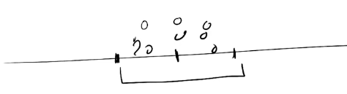
Refer to the diagram suppose u have data and in the center u have the mean or your center data and on the right and left u have ur highest value and the lowwest value we can see how close or how far these values are to check how spreaded the data is between them.

Interquartile Range(IQR):
Before moving towards Interquartile we first need to understand what are Quartiles. Because in IQR we will be measuring the distance between one quarter and another quarter of our data.
There are mostly 3 types of percentile and sometimes 4 types of percentile.
Q1-25% Percentile
Q2-50% Percentile
Q3-75% Percentile
Q4-100% Percentile

Percentile means the percentage of data that lies below a specific value.
To understand this better let see a data we have a data
12,12,13,14,15,17,20,20,28,29,31,35,46,46,48,51,59,60

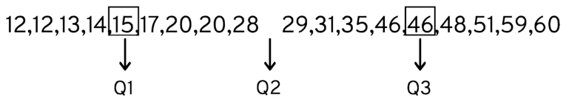
We can calculate Q1,Q2,Q3 by dividing the data into two parts like in the data we have 18 elements we can divide them into 9 9 parts for which then we can calculate the data. For the calculating Q1 we can see the 5th value of the data that will be Q1 for the Q2 we can do is divide the 9th and 10th element and we can get Q2 which exactly means the mean of the data. And for Q3 we will do the same thing but with the second part of the data choosing the 5th value of the data it will be Q3.

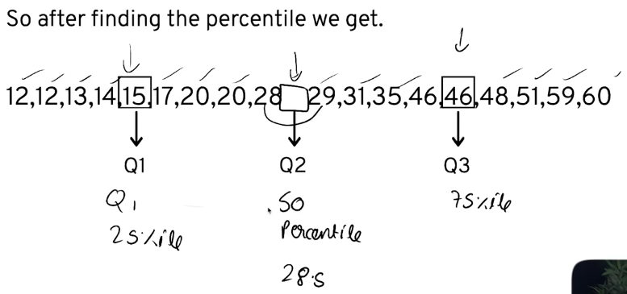
Now to find IQR we just have to subtract Q1 From Q3 46-15 = 31.
So if the IQR is low it means the data is close to the median if the IQR is high it means the data is highly spread from the center.

Outliers:
To understand outliers we need to look at an example of data first only in that way we can understand what really outliers are
1,2,4,7,9,10,101.
Lets find the central tendency of this data we will be using mean and median since we cant use mode because there are no repeated values.
Mean → 1+2+4+7+9+10+101 = 134/7 → 19.4
Median → 1,2,4,7,9,10,101 = 7

Here u can see how much big difference there is between the mean and median its due to an outlier (101) and if we remove that mean and median would be very close then.

Outliers damage our data by:
- They distort measures like mean and standard deviation making them less representative to the given data.
- In machine learning especially in regression models outliers can disproportionately influence the model leading to poor generalization.
- Outliers impact our model performance our statistical testing and many other thing so we have to get rid from them.
So now to get rid of outliers we use the upper and lower fence approach in our data by that we can get rid of them.
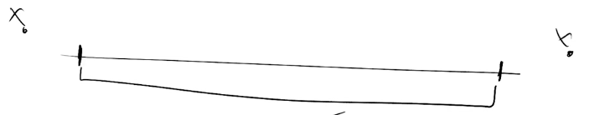
The points that show linking between them is the point till we consider our data after the end line no data will be considered.

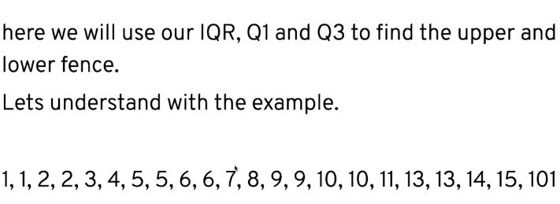
(Mathematical calculation done is notebook)

To find upper and lower fence we have Formula to calculate each fence.

Upper Fence → Q3+1.5(IQR)

Lower Fence → Q1-1.5(IQR)

For this example we got this after calculations

IQR = 7
Q1 = 4
Q3 = 11

Upper Fence → 21.5

Lower Fence → -6.5

We have to check whether there is any value below lower fence or any value above the upper fence if those exists they are outliers.

5 Number Summary:
The 5 number summary is prepared after removing outliers from the data it is a statistical summary used to describe the distribution of a dataset. It provides a quick overview of the data’s spread and center and it includes the following values:
- Minimum
- First Quartiles (Q1)
- Median (Q2)
- Third Quartiles (Q3)
- Maximum
Lets work with data
2,4,7,10,15,20,25,205 calculations done in notebook
Data after doing calculations
Q1 = 5.5,Q2 = 12.5,Q3 = 22.5,IQR = 17,UF = 48,LF = -20

Preparing 5 Number Summary After Removing Outliers
Min → 2
Q1 → 4
Q2 → 10
Q3 → 20
Max → 25

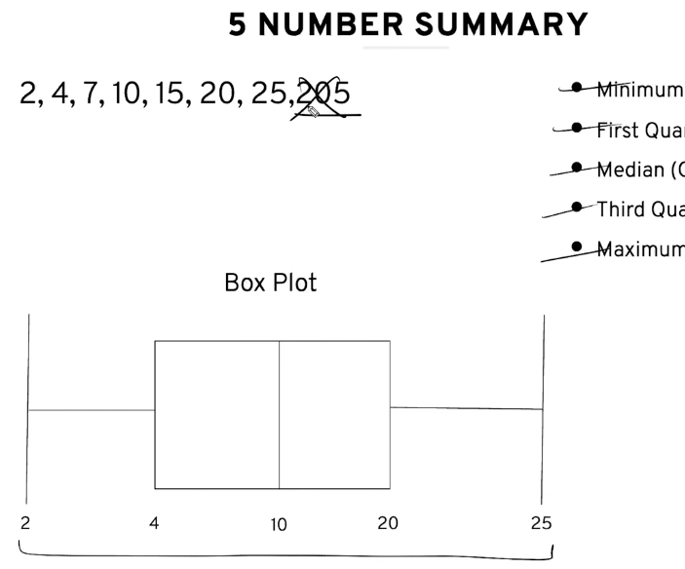
This summary is used for plotting box plots u will understand better when u will see data visualization.

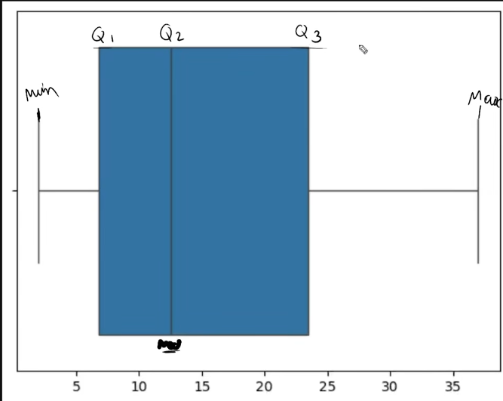
(We have also implemented Code for outliers too see In the repository)

DATA DISTRIBUTION
In this section we will create a base about hypothesis testing.
We will learn about kernel density estimation curve what we draw in histogram. We will also see how the data is spread around the mean.

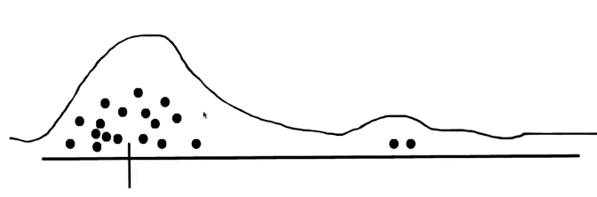
Lets see with the example of a distribution. In the below distribution we can see how the curve is disturbed because of two outliers that’s the sole reason why our bell curve/ kernel density estimation curve is a bit odd.

In this section we will see how data distribution starts with a histogram then it becomes frequency polygon and eventually turns into a density curve.
Histogram → Frequency Polygon → Curve

Normal Distribution:
Distribution which always forms a bell shaped curve. Its used in many areas.

MEAN, VARIANCE AND STANDARD DEVIATION:
Before we begin lets understand what basically is sample and population in stats
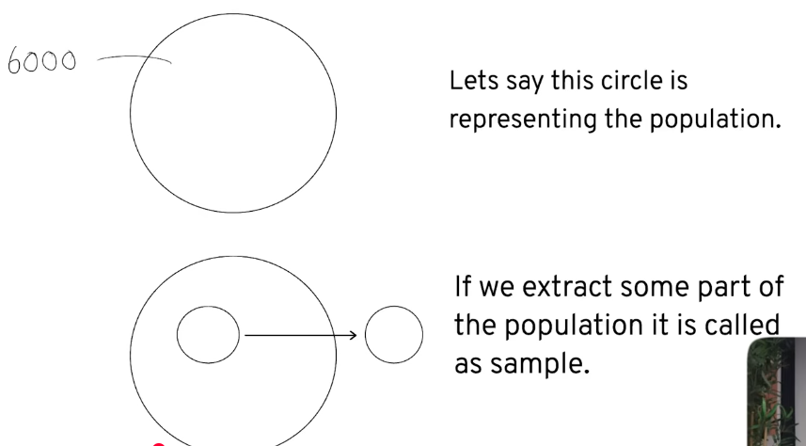

To understand properly what a sample is lets take an example of a medicine like we have created a medicine for cancer we have to test it so we can’t test on all people so what we will do is gather people from around the globe lets take an example like we take out 500 people from different regions and what will be the result of that test will be considered for the whole population. This is done in Inferential Statistics. We will do it later.
Note: When discussing Mean, Variance and Standard Deviation. It is important to clarify that whether we are referring to a population or standard deviation. As formula for each differ.

Variance:
Variance is a statistical measure that quantifies the spread or dispersion of set of data points around their mean.
In short variance tells the value of the data which is clustered around the mean or how the data is spread around the mean.
To find the variance we first see a data a simple one:
85,90,95,100,105
→ Find Mean first = (85+90+95+100+105)/5 = 95
→ Then Find the computed difference to find it we will be doing this subtracting the data numbers with mean and wrapping each block with square adding them

→ Now just divide the computed difference with no of elements and here we can see the value of variance → 250/5 = 50
50 here is the variance value
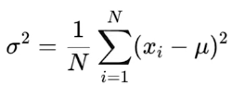
← Formula of variance in statistical terms. Lets break it down what each means for instance (This formula is for population).
N means no of elements, i=1 means no of elements we will be moving as the elements number increase
g small n. Mean of population is represented by meow and for sample it is represented by x bar. And to represent mean of population we will be using sigma symbol with a square and for sample we represent using small s with square. Standard deviation is represented sigma and small s sigma for population and small s for sample
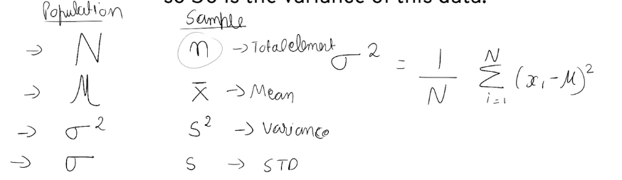
(Proper breakdown of each thing is present in the notebook typing here is a challenge for me.)

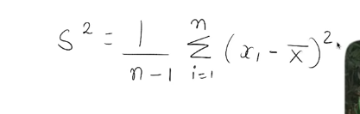
If we want to calculate variance of sample the formula just becomes this →

Standard Deviation:
Standard Deviation is just the square root of the variance its as simple as that. The symbols will be changed depending on for what u r taking standard deviation of is it population or sample.
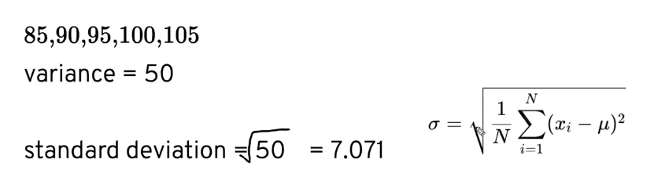
Basically standard deviation follows the same process u first take out mean then distance(computational difference) then divide it with total number of elements.
NOTE:
By default use sample formulae unless population or entire or anything related to this is mentioned.

Q: What does it do?
A: Standard deviation tells that how much distance should be between the mean and the points.
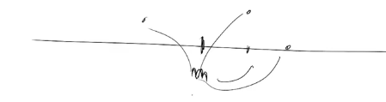

Density Curve:
To understand this concept first we need to understand what is histogram as we already have discussed histogram I will not be discussing here again.
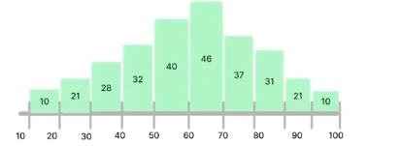
Steps To Create a Density Curve:
- First create a histogram just like this →

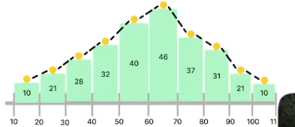
- Now we just have to plot points above the histogram and connect them just like we were doing for line graph just like this →

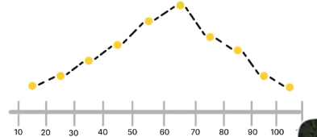
- After this we have to remove the histogram bars. The fewer bin we use the more inaccurate the frequency polygon we will get. Now we have a frequency polygon just like this →
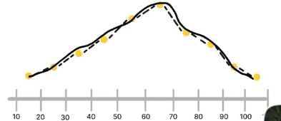
- Now imagine u are using more bins the dots will become more closer and eventually it will become smooth,continuous probability curve which is also known as a density curve.

Now this density curve tells us many things like for this histogram we want to know how much percent of data we have for the people aging between 80-100 we can easily tell that. We will be learning a concept known as z-score from it we can easily tell these types of data. For now we have understood how this curve is made.

Types Of Curves:

Symmetrical Distribution:
Symmetrical Distribution also known as Normal Distribution or Gaussian Distribution.

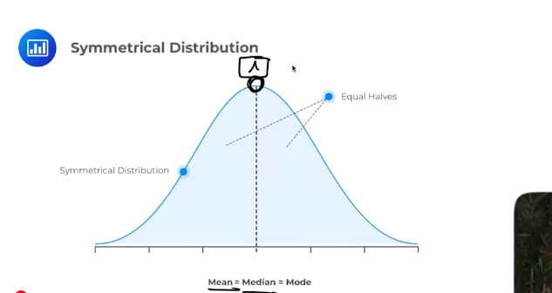
The center line u can see in the picture in this distribution this is the mean median and mode.
Let me explain this concept in the data if the data is normal its obvious the mean or the average value of data would be something that is center of them. Median is already the center of the data. Mode u can see in the picture that the density curve is at its peak in the center so that possibly means the value is repeated in the data that’s why it is at its peak. This explains how mean , median and mode lies in the center of this data.

In this distribution u can see both sides right and left sides are equal. This is the thing for this distribution that they are equally distributed in both sides left side and right side.

This distribution always forms a bell shaped curve. We will talk about this distribution in the upcoming chapters.

Right Skewed Distribution And Left Skewed Distribution:

First lets see what skewness is before discussing these distributions.
Skewness:
It is the measure of the asymmetry or imbalance in a dataset. In a perfectly balanced data such as normal distribution. The data is perfectly balanced and aligned means that the mean median mode are aligned too. When a data is skewed it indicates that the distribution is not a mirror image on both sides meaning that the data is tilted or spread out more towards either lower or higher values.
When the data is skewed your mean,median and mode appears to be a bit unbalanced as u can see in the picture below how those all are unbalanced in the below right skewed distribution.

Right Skewed Distribution:
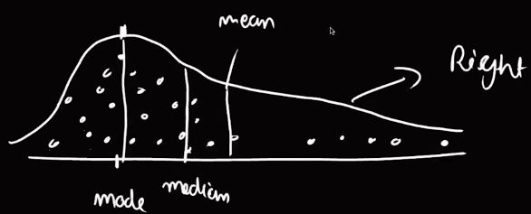
A right skewed distribution is a distribution where the mostly data lies in the left direction. Meaning that the distribution is properly being made on the left side and on the right side the data is skewed it could be due to many things such as outliers or anything else. Then the distribution is said to right skewed.

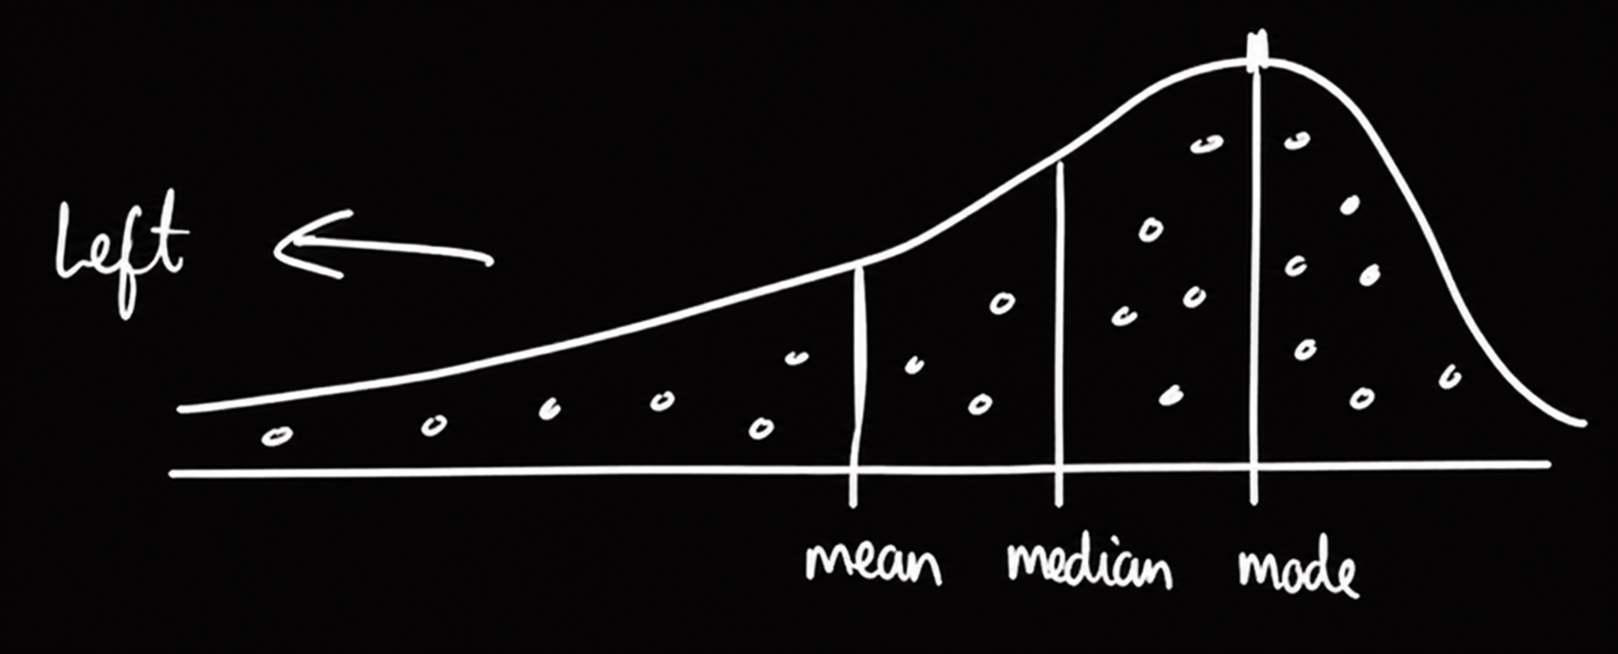
Left Skewed Distribution:
A left skewed distribution is a distribution where the mostly data lies in the right direction. Meaning that the distribution is properly being made on the right side and on the left side the data is skewed it could be due to many things such as outliers or anything else. Then the distribution is said to left skewed.

NOTE:
- Mean will always lie close to the tail.
- Mode will be there where most of data exist.
- Median will be in the center as usual.
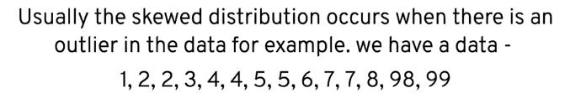
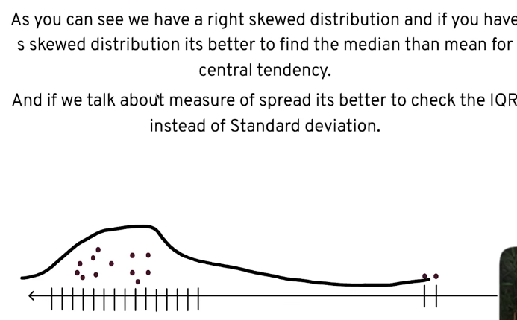
If we need to calculate the central tendency of a skewed data we need to calculate median. But if its for normal distribution we will need to calculate mean first.
And if u are calculating measure of spread for skewed data we need to calculate the IQR and for normal distribution its better to calculate standard deviation first.

Z-Score:
Now we have already seen the normal distribution and they are very important in data as well as probability distribution.
The area under the normal distribution is always 100% or 1.
(100% = 1, 99% = 0.9)
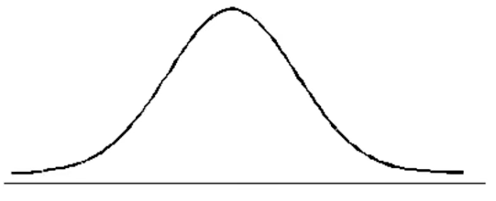

Now this normal distribution follows a formula known as Empirical Formula. Its basically a kind of rule that is followed in Normal distribution. The rule is simple 68-95-99.7 rule.
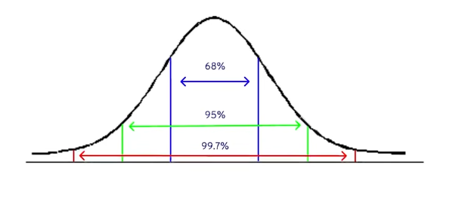
You might be thinking what are these numeric things here don’t worry I gotchu.
We divide the distribution into 3 section following the Empirical Rule.

The percentage means probably this amount of data lies between these. Like if u see the blue arrows in between that there is a probability that 68% data lies similarly for green lines and arrows there is a probability that 95% of data lies here and for red arrows and line there is a probability that 99.7% data probability lies here.
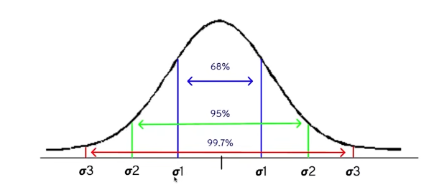
Now a question might rise like how these lines are divided? The simple answer to this question is these lines are divided using standard deviation points.
Means that we will have a data and from that data we will be calculating the standard deviation points. Then we will be doing what is like draw lines from the standard deviation point 1 on the left side of mean to the right side of mean here we got our first point similarly a point after the first standard deviation point from the right side and left side here 95% data will lie then for the third one we will do the same. This all will be done when the distribution is normal and a bell shaped curve is formed.

These percentage means like the probability of getting 68% data lies here then 95% here and 99.7% lies here.

In short the probability of getting 68% data lies between std point 1 on both sides. 95% probability of getting data lies between std point 2 on both sides similarly for the 99.7% percent probability of getting data lies between std point 3 on both sides.

Now lets see this with an example of a consistent data
1,2,3,4,5,6,7,8,9

(Detailed calculation is done in the notebook)
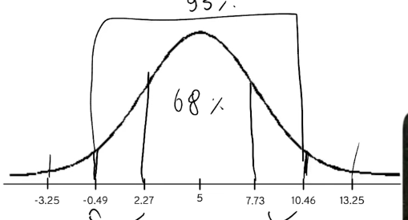
Mean = 5
Standard Deviation = 2.73
Now for plotting we will keep 5 as center and subtract 5 from 2.73 for left side. And add 2.73 with 5 for right side. 5 will be center because its the mean.
5 will be subtracted or added then the new value that we will get in that value we will add or subtract the standard deviation.

\

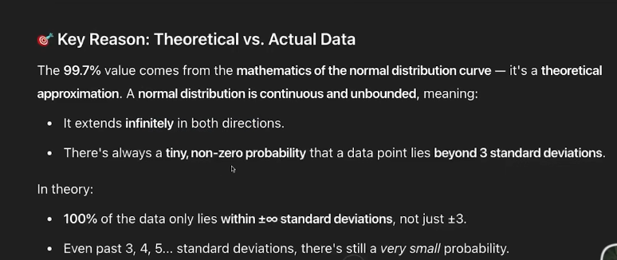
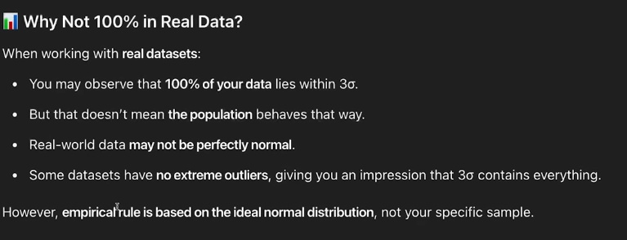
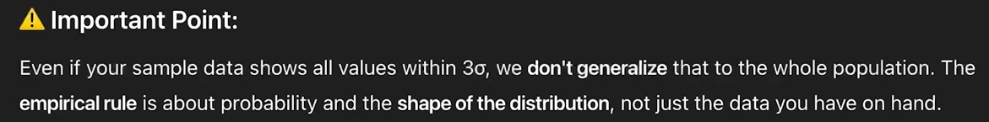
In simple words this means that it is not necessary that the data lies between three standard deviation points in real life it may differ it could be due to an outlier which can cause things to behave differently. For proper understanding read all three attached pictures. In the above example we can clearly see all the data lies between 3 std points.

Now let’s discuss what Z-Score is :
A Z-Score is a powerful statistic tool which is used for measuring how far a data point is from the mean of a dataset, it is measured in terms of standard deviations.
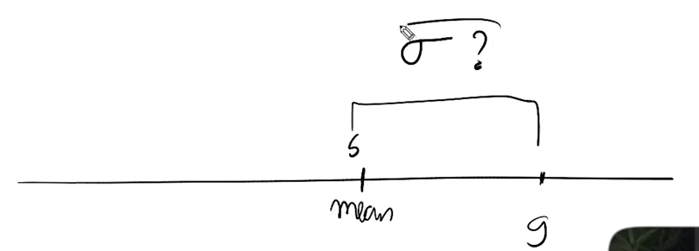
From the attached example we have a dat in which by using z-score we will measure how much far the data point 9 is from the mean. It is measured using standard deviation.

Formula Of Z-Score:
Z-Score = (data point – mean)/standard deviation

To understand this we will be using an example data point we have is 9.5 and mean for it is suppose it is 8 and standard deviation is 1 (usually 1 is not the standard deviation is using just for easy calculation). Now lets calculate the z-score

Z-Score = (9.5-8)/1 = 1.5

This means 9.5 is 1.5 standard deviation away from the mean.
If the z-score value is positive then it means its on the right side of the mean if the value is negative then it means its on the left side of the mean.

Z-Score can also calculate the total percentage of data below a specific point. To do this we will use z-score table.
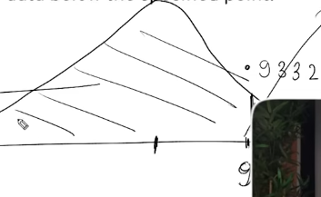
For seeing the z-table go to chrome and search z-table there will be multiple sites available. Coming towards our example first we calculate our z-score which was 1.5 and then we look at z-table we will search 1.5 since we have nothing after 1.5 we will look at 0 and the value for that is 0.9332.
This means that the data below that point holds 93.32% data. To determine how much data is above that point simply we will be subtracting 100-93.32 = 6.68% data lies above this point
PROBABILITY
Think about probability like of an event occurring as a likelihood that it could occur.
Probability = Likelihood
For example like probability of rolling 6 on a dice.
Statistics and probability goes hand in hand because stats is about data and analysis of data.
Probability is going to allow us to determine how reliable our statistical result actually are.
So for that reason we will be studying probability and stats together.

Road-map of what we will study in Probability

Step 1 – Basics Probability Concepts
Step 2 – Types Of Events
Step 3 – Probability Rules
Step 4 – Conditional Probability
Step 5 – Bayes’ Theorem (Important for ML Algorithm)

Lets start with probability. A probability always comes between 0 and 1. We can also tell it in percentage form or fraction form its same thing.
Formula:
Probability = True Outcome / Total Outcome
Lets take an example of tossing a coin and lets determine the probability of getting heads.

Total Outcome will be 2 as only 2 can come heads or tails. And the true outcome would be 1 because we can only get heads one time.
P(H) = ½

P(T) = ½

In short there is 50%-50% chance of getting a heads.

What is the probability of getting a 4 when we roll a dice?
P(4) = 1/6 => 1 because we can only get 4 one times, while for 6 its the total outcome is 6 because we can get 6 occurrence when we roll a dice simple. SO the chance of getting 4 is 16.6%
TYPE OF EVENTS IN PROBABILITY

Independent Event:
Those event that does not affect the occurrence of the other event. For example when we toss a coin and here comes heads if I will toss the coin again and tails comes this does not affect the occurrence of the previous event the probability for both the events will be calculated differently.
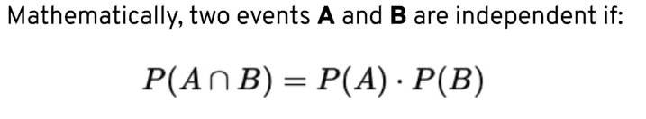
Lets continue with the previous example

Let A be the event that the first toss is Heads.
Let B be the event that the first toss is Tails.

These two events are independent because they don’t affect the occurrence of second event.

P(A) = ½, P(B) = ½, P(A n B) = ½* ½ = ¼

Dependent Events:
In probability dependent events are those events where the occurrence of one event affects the probability of the other.
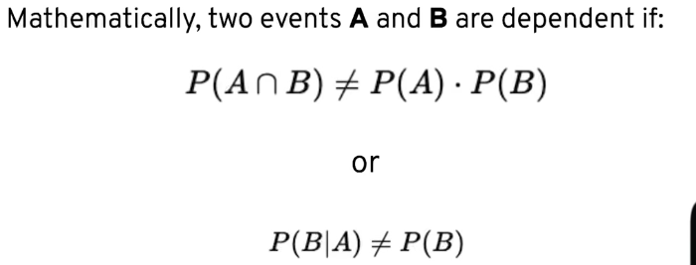

Lets see an example of this:
Suppose we have 52 cards (I don’t have much knowledge of these cards if I make mistake ignore it concept will be the same)

Let A be the event of drawing ace on the first draw.
Let B be the event of drawing ace on the second draw without putting the first card back.

Since the first card is not replaced,the total number of card is now 51. So the probability of B is affected due to A – they are dependent.

P(A) = 4/52 , P(B|A) = 3/51
According to formulae:
P(A n B) = P(A)*P(B|A)
= 4/52 * 3/51
= 1/221

Mutually Exclusive Event:
These are events which cannot happen at the same time. Two event A and B are mutually exclusive if:
P(A n B) = 0
That means that the probability of having these two events together is 0.

Lets see this event with an example:
Suppose u are rolling a dice and now lets find out can u roll 1 and 6 together this is impossible as you are rolling a single dice. This is an example of this event.

(This event is not mostly asked even in hypothesis testing but still you have to know about it)

RULES OF PROBABILITY

Addition Rule:
The addition rule helps us to find the probability that at least one of two events occurs i.e. the probability of A or B happening.
In probability language → P(A U B) = P(A)+P(B)
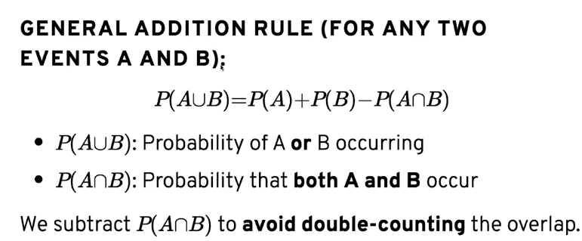
Whenever there is a question related to addition rule we mostly get choices between multiple things word like or,either and similar words that depict choices are present.
Lets understand with an example:
What is the probability of drawing a red card or a king.
For instance there are 26 red cards in a deck of card and 4 kings among which 2 kings are red
P(A)= 26/52
26 means red cards and 52 are total cards
P(B) = 4/52
4 means king cards and 52 are total cards
P(A U B) = P(A) + P(B)
=26/52 + 4/52
You might think that this is the answer it could be but here is a catch in king cards there are 2 black and 2 red cards in the p(b) we took all 4 cards as a king while 2 red kings are already in the red card probability so properly we will be writing it as
26/52 + 4/52 – 2/52
subtracting 2 red kings as they are already in the red card
answer will be 7/13
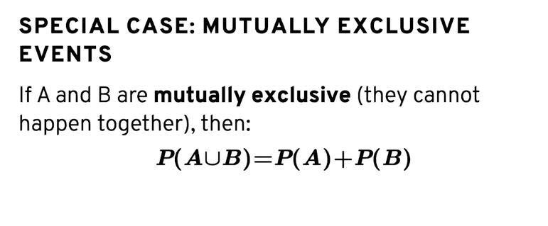
Example of this scenario is as follows:
Rolling an even number in a fair six sided dice
Rolling an odd number in a fair six sided dice

P(A) = 3/6 → (3 because only 3 even numbers can actually come)
P(B) = 3/6 → (3 because only 3 odd numbers can actually come)

P(A U B) = ½ + ½ = 2/2 = 1 Simple answer

Multiplication Rule:
Multiplication Rule is used to find the probability of two events happening together i.e. the probability of A and B occurring.
In probability language P(A n B)

For Independent Events:
If A and B are independent then
P(A n B) = P(A).P(B)
We use this when one event does not affect the another event.

For Dependent Events:
If A and B are dependent then
P(A n B) = P(A).P(B|A)
Use this when the probability of B depends on whether A has occurred.
For better understanding we will see an example like drawing a king for two times.
P(A) = 4/52
and for drawing the king again the probability will be
P(B) = 3/51
because a king is already drawn before.
Conditional Probability
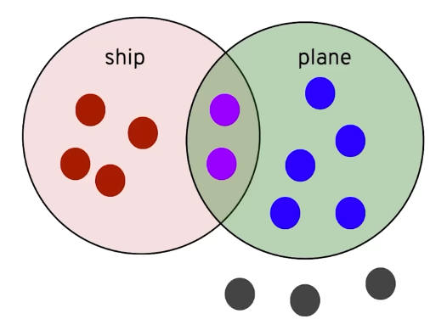
Suppose this is an example of the conditional probability we can see that approx 4 people loves ship, 5 people loves ship, 2 people loves both of them and 3 people don’t like anything.

(This is an independent event)
For better understanding and solving these type of questions we should prepare a contingency table.
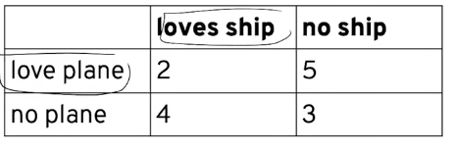
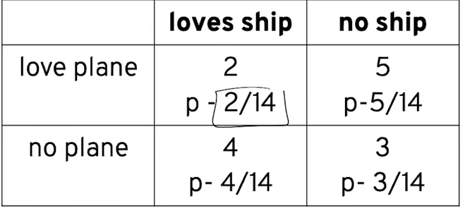
Now lets calculate their probability →

(For better understanding look in notebook their calculations have been done properly and visually too.)

Now we will calculate the total of rows and columns too
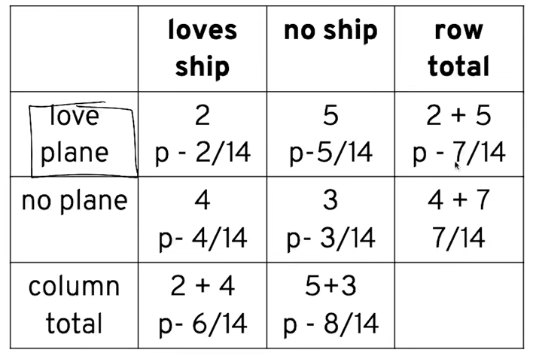

Now we will see what type of question we get
A Person who loves a plane what is the probability of him loving ship too
There are total of 7 person who loves plane out of them only 2 loves ship too. The probability will be 2/7. We solved this logically let see the formula approach too.
Formula → P(A|B) = P(A)/P(B)
P(A) → Probability of a person who loves plane and ship
P(B) → Probability of a person who loves plane
P(A|B) = 2/14 / 7/14 = 2/7

Condition probability are also used in Dependent Events its simple too the formula differ
Formula → P(A n B) = P(A)*P(B|A)
Lets see an example there are 3 white balls and 2 red balls what is the probability of getting 2 white balls
Its simple:
P( A n B) = 3/5 * 2/4 = 3/10
P(A) here means the total of white balls we have and P(B) here means the probability of getting 2 white balls we used 2/4 because we have to calculate the probability of getting 2 white balls so we subtracted 1 ball from the total and white ball too.

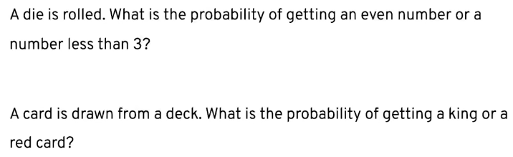
Questions related to probability are done in the notebook we have done Questions related to Probability, Rules of Probability, Conditional Probability in the notebook.
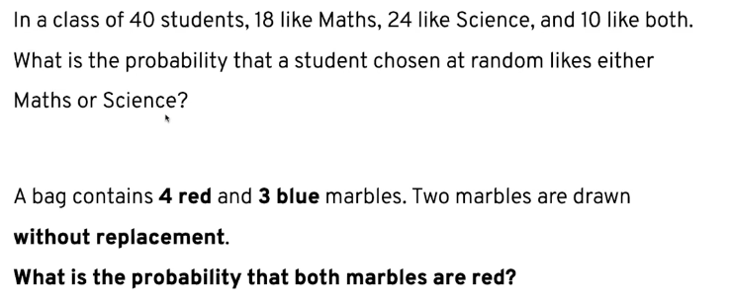
More Questions done in the notebook.

BAYES’ THEOREM

Bayes' Theorem is a probability theorem that helps us find the probability of an event or cause after observing some evidence that support your result.

It is used to determine the most likely cause of an observed event by updating our prior belief using new information.

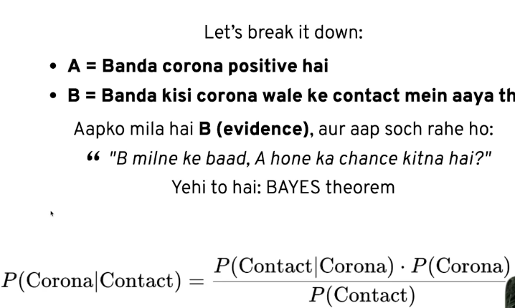
Example:

Formulae:
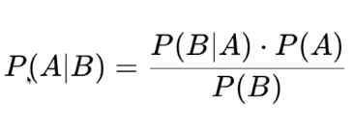

The questions related to this theorem are very big to solve these we need to do case theories but here we are solving a basic question (Solved in notebook):

Lets say we have 2 dice one dice is fair and another dice is weighted as the chance of getting a 6 on that dice is 50%.
1-Fair Dice
2-Unfair Dice

Scenario→ We choose one of the dice without knowing which die we picked
We roll the dice and got a 6/

Now calculate the probability that we picked the biased dice given that we rolled a 6

To solve this we are going to break things as follows:
A-Choosing Biased Die
B-Rolling a Dice
So
p(A|B)→p(Biased|6)
p(B|A)→p(6|Biased) = 1/2 (reason in the notebook)
p(A)→p(Biased) = 1/2
p(B)→ p(6) = p(biased * rolling 6) + p(fair * rolling 6)
= 1/2*1/2 + 1/2*1/6
=1/3

Lets put the value in the formulae:
p(A|B) = ½ * ½/ 1/3 = ¾ answer (proper calculation is done in the notebook with reason and working refer to that)
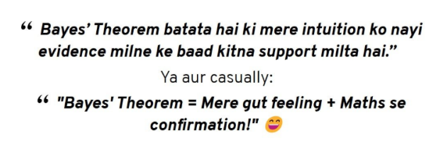

Before we begin with hypothesis testing lets understand the difference between descriptive and inferential statistics

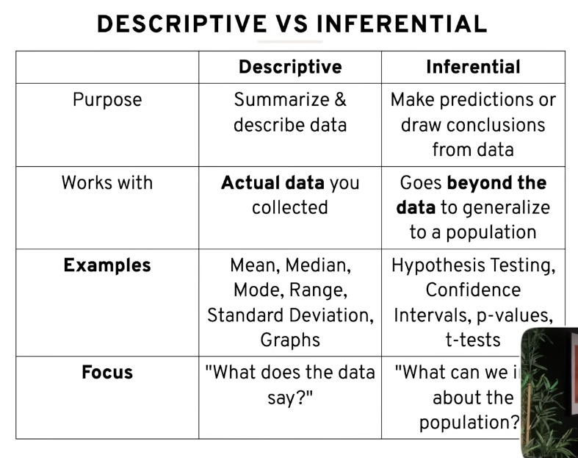
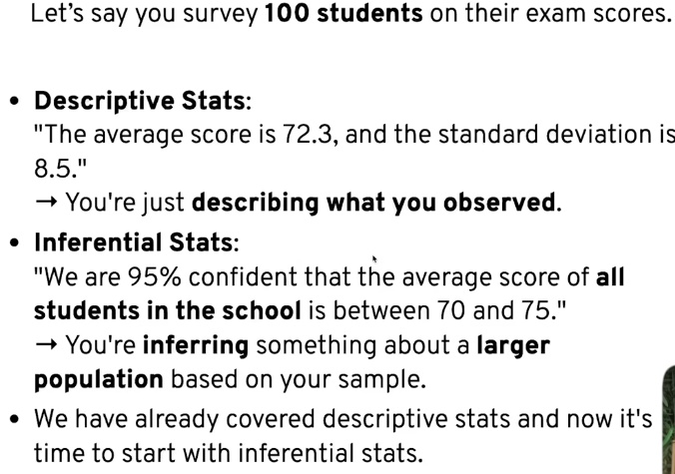

Inferential Stats

It is the branch of statistics that helps us to make predictions or decisions about a population based on a sample of data.

Hypothesis Testing

A hypothesis testing is a statistical method used to decide whether there’s enough evidence in sample to support a claim about a population.

Lets see with an example how hypothesis testing works:

I have a coin and I want to test whether a coin is fair of not by flipping in 100 time.

p(h) = 0.5 and p(t) = 0.5

If we think logically we can assume that if a coin is flipped 100 times 50 times head will come and 50 times tails will come but sometimes this will not be the case.
To test that our coin is fair we will be using hypothesis testing and for hypothesis testing we have to define 2 hypothesis null and alternate.

Null Hypothesis → Coin is fair.
Alternate Hypothesis → Coin is unfair.

Null hypothesis is always seen the positive side because there is a quote ‘Innocent Until Proven Guilty’.
Alternate Hypothesis is just the opposite side of Null Hypothesis.
The third thing we will do is do an experiment.
After experiment we will Accept or reject the null hypothesis.

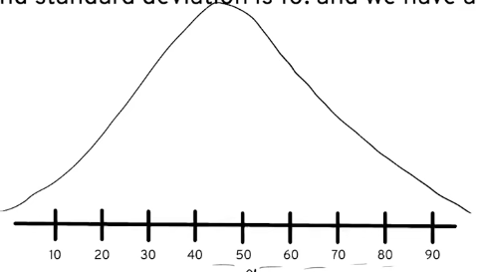
For this question lets say before doing the experiment we got the information that our mean is 50 and standard deviation is 10 and the distribution is normal. Now we can create a bell curve over the plot just like this.

Now suppose I performed the experiment and I got heads 30 times. So can we say that our coin is fair or not? So to see whether our coin was fair or not our experiment head count must be close to mean but how much close for this we will use an important concept of significance value.

Significance value is set by the domain experts and lets say the significance value is 0.05 and it is denoted by α → Alpha sign. And using this significance value we calculate the confidence interval
Confidence interval = 1-Significance value = 1-0.05 = 0.95.
Confidence interval means u are in the zone where u can determine that your coin is fair
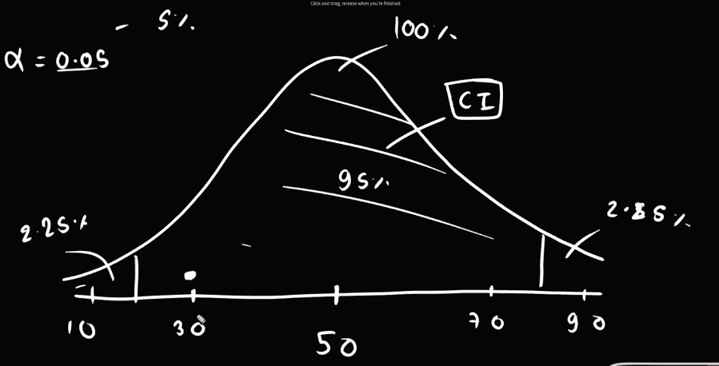
(Domain experts are those who work in stats and create theories and much more. Usually there are mostly 3 values for significance value 0.10,0.05,0.01. If the value is not given we use 0.05 it is denoted by α.)
Looking at the image that I extracted from the video. We can see the above example properly drawn the two tales thing is something which Is covered in the upcoming topic too. The two tales were made by dividing the significance value by 2 splitting the data into two tails and the remaining part is the confidence interval that means if the data lies between those lines we can be confident and choose our null hypothesis and if the values lie outside of the tail we can clearly say we reject our Null hypothesis.
Further details of this will be covered in the upcoming topic.

Type 1 And Type 2 Error:
In this scenario, the null hypothesis () is that a person does not have COVID-19, and the alternative hypothesis () is that the person has COVID-19.
- Type I Error (False Positive): This occurs when the test result indicates the person has COVID-19, but they are actually healthy. The speaker notes this is like falsely telling a healthy person they are sick.
- Type II Error (False Negative): This occurs when the test result indicates the person does not have COVID-19, but they are actually infected. The speaker describes this as a more dangerous error, as a sick person is told they are healthy and may continue to spread the virus.

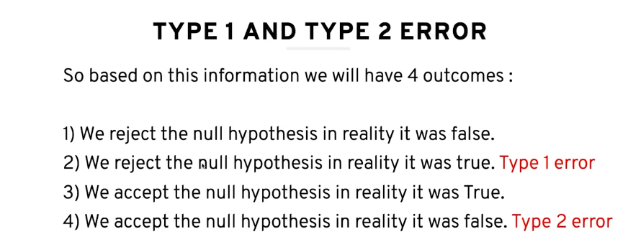
Confusion Matrix:
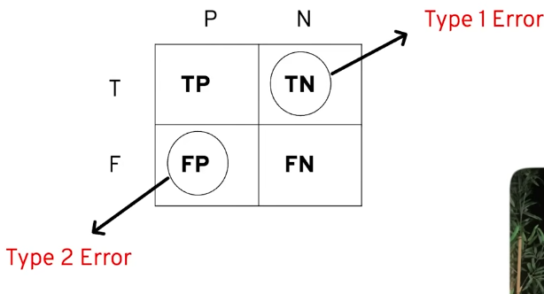
An important concept in machine learning based on all the outcomes we can create like this

One Tailed And Two Tailed Test:
This is the one tailed and two tailed thing we were talking about before to determine how many tails one or two we have to use for the test lets understand with an example You have created an application and u claim that students who study through your application scores on an average of 70 marks in a particular subject.
Now u want to verify this claim in statistics You collect a sample of 30 students who uses ur application to verify.

Since u have claimed that students who use ur application score 70 marks and haven’t given any specific range we can clearly see we will be using a single tail because there is only a single claim. The significance value we had will only implies with one tail no dividing them and splitting them.
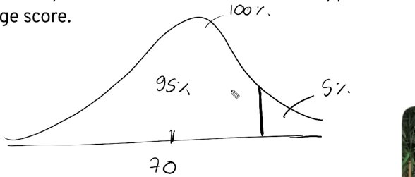
The 5% data left will go in the tail. While the other 95% data will remain in the center.

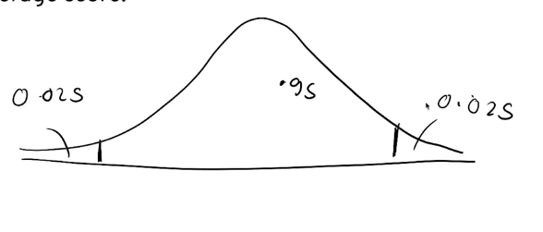
Coming towards the 2 tail thing we will be using the same example just twisting it like before we have used an example of students scoring 70 marks in subject here we will be making it like different than 70 it will mean above or below 70. Now we have a thing like above or below we will be using two tails like dividing the significance value with 2 so distributing them equally on 2 halves. Just like the above image we are seeing the 95% data will lie in the center while the 2.5% and 2.5% of data lies outside of both the tails. I hope u got my point if still didn’t got my point look at the video we will properly learn this once we solve these questions.

